Big Data in Behavioral Health
Devasirvatham Mark Preetham
Master of Science - Data Analytics in Business, Seattle Pacific University
ISM 6362: Big Data and Cloud Based Tools
Prof. Anthony Kwiatkowski
7th June 2026

Overview
Mental health conditions and substance use disorders are among the most significant public health challenges facing governments and communities worldwide. As the demand for behavioral health services continues to increase, there is a growing need for data-driven approaches that can improve the identification, assessment, and support of vulnerable populations.
The primary objective of this project is to uncover the social, economic, and environmental factors that contribute to mental health challenges and substance misuse—factors that are often overlooked when relying solely on traditional clinical and numerical healthcare data. By integrating and analyzing the datasets, the project aims to identify high-risk population profiles associated with substance use and overdose incidents.
The insights generated will enable healthcare providers, public health agencies, and policymakers to proactively allocate resources, improve intervention strategies, and adapt health services and prevention programs in near real time. Ultimately, the project seeks to support earlier intervention, reduce overdose risks, and improve health outcomes for affected communities.
Business Problem
Cloud Health Clinic is a healthcare analytics company that partners with State Mental Health Agencies (SMHAs) across the United States. These agencies collect millions of client records annually through the SAMHSA Mental Health Client-Level Data (MH-CLD) system. Despite the vast amount of available data, most of the information is only utilized in static annual reports that are generated months after the reporting period, limiting its value for timely clinical decision-making.
A key challenge facing mental health providers is the lack of real-time insights to identify newly enrolled clients who are at the highest risk of requiring intensive services. As a result, case assignments are often distributed evenly among providers rather than prioritized based on client severity, risk factors, or anticipated service needs.
In addition, there is no automated mechanism for comparing an incoming client's demographic, socioeconomic, and diagnostic characteristics with historical patient cohorts. Without these data-driven recommendations, intake coordinators must rely heavily on manual assessment and professional judgment when determining the most appropriate care pathway. This can lead to delays in treatment, inconsistent placement decisions, and inefficient allocation of healthcare resources.
The project aims to address these challenges by developing predictive analytics models that identify high-risk clients at intake and recommend evidence-based service pathways—including community-based care, inpatient treatment, residential programs, or justice-system-related services—based on outcomes observed in similar historical cases.
Business Solution
Streaming Use Case — Real-Time Intake and Update
When a new client is enrolled through an SMHA web portal, their intake form is published as an event to Amazon Kinesis. A Databricks Structured Streaming job consumes that event within seconds and scores the record against the pre-trained clustering model, returning a risk-tier profile. The result is written back to the client profile, so intake coordinators see a real-time recommendation before the first clinical appointment.
Batch Use Case — Annual & Monthly KPI Reporting
Four years of historical MH-CLD R-format datasets (2021–2024) are loaded from the SMHA website into Amazon S3 Bronze storage. A nightly Databricks batch job, dedicates, and transforms the data before writing enriched records to S3 Silver. Every morning a second job computes the three dashboard KPIs below and writes aggregated summary tables to S3 Gold via the clustering model, which feeds a Microsoft Power BI Health Dashboard visible to SMHA leadership.
Machine Learning Use Case — K-Means Client Clustering
The Silver-layer dataset feeds into a K-Means clustering model built in Databricks ML. Using demographic variables (AGE, SEX, RACE, ETHNIC), diagnostic flags (MH1, SAP, SMISED, NUMMHS), and service-utilization indicators (SPHSERVICE, CMPSERVICE, OPISERVICE, IJSSERVICE, LIVARAG, EMPLOY), the model groups clients into behaviorally and clinically distinct cohorts. The model is retrained quarterly on the latest silver data, and its outputs are surfaced both in the batch dashboard and in the real-time streaming pipeline.

Data Pipeline
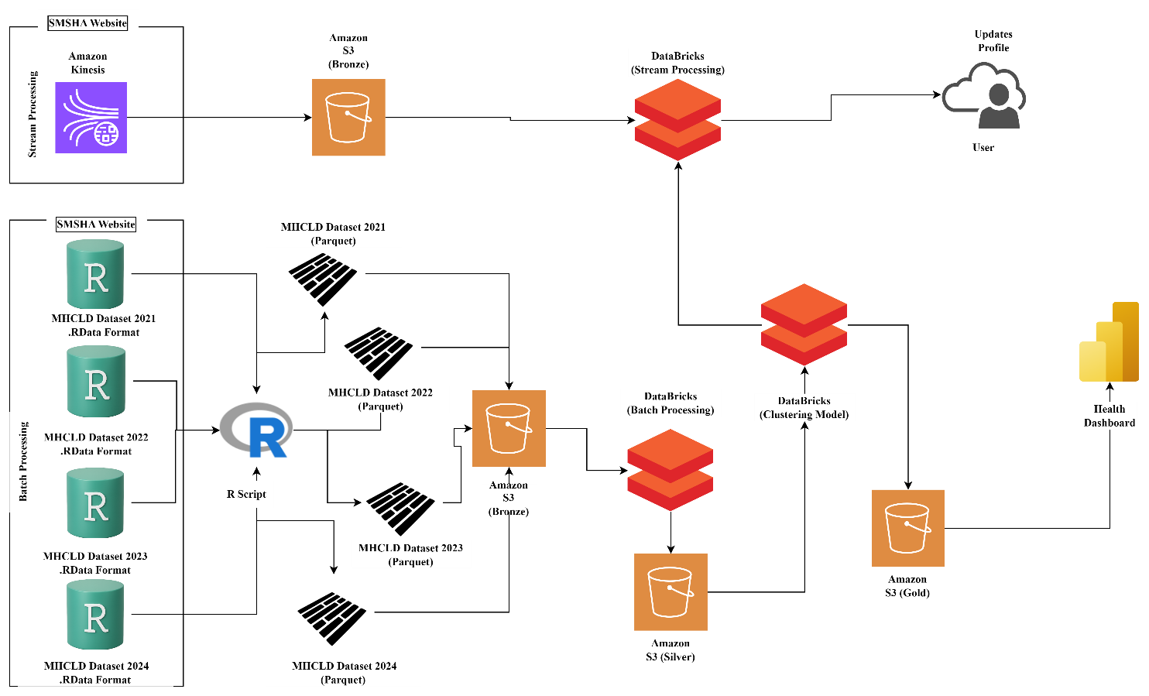
Stage 1 — Data Sources
Source A (Batch): Annual MH-CLD datasets for 2021, 2022, 2023, and 2024 are downloaded in RData - format from the SAMHSA/SMHA public website. Each file contains one record per client served during the state's 12-month reporting period, covering ~6–7 million rows per year. These files are uploaded to Amazon S3 Bronze Tier Storage in their raw, unmodified form, partitioned by year.
Source B (Stream): Live client intake events arrive through the SMHA web portal. Each enrollment form submission generates a stream event that is published to an Amazon Kinesis Data Stream. The stream acts as a durable, ordered buffer that decouples the portal from all downstream processing. For this project, a sample population of batch data is stimulated as streams to showcase streaming use case.
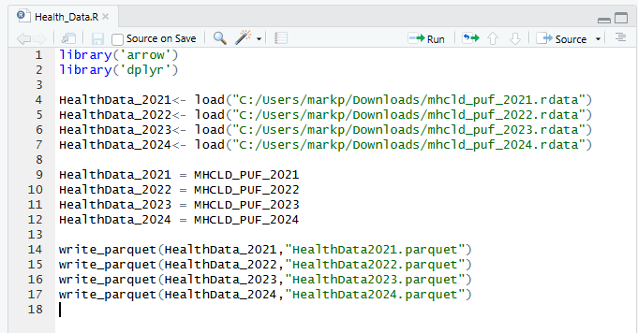
Stage 2 — Data Transformation (RData -> Parquet)
The Data sets from SMHSA Website were retrieved in the form of. RData Files which were further transformed into Parquet Files using a simple R Script. This step allows us to directly ingest the RData without need for explicit libraries in Python and allows us to directly ingest the batch data into Amazon S3 partitioned by year.
Stage 3 — Data Lake Ingestion
The Datasets from both the Batch layer and stream layer are ingested into the Data Lakes in the bronze (raw) tier. This allows for accessing the data for various tasks without any need for making changes to original data. Batch Layers will ingest data periodically, while stream layer will ingest data continuously in real-time. Data in this layer will be in parquet format.
Stage 4 — Batch Processing (Databricks Batch Jobs)
A scheduled Databricks notebook runs nightly on the S3 Bronze historical files. The job performs: schema standardization across all four years; variable recording according to the MH-CLD codebook (e.g., collapsing MARSTAT divorced/widowed, bucketing AGE into the 14 defined groups); deduplication on CASEID; and creation of derived features such as a economic status or factors or demographic impacts on disorder indicator. The cleaned output is written to S3 Silver as Parquet files.
Stage 5 — Silver Layer (Cleaned & Enriched)
S3 Silver holds the cleaned model-ready dataset. Each record is a deduplicated client row with all variables aligned to a single schema and all flag variables (ANXIETYFLG, DEPRESSFLG, SCHIZOFLG, etc.) verified for internal consistency. Silver tier data acts as the input layer for the clustering model to gain insights.
Stage 6 — Clustering Model (Databricks ML)
A Databricks ML job reads from Silver and trains / evaluates the K-Means model. Hyperparameter tuning (number of clusters k) is tracked in the workbook. The best model artefact is registered in Registry and promoted to 'Production'. The productions stage then applies the model to incoming Kinesis stream queries which classify the datapoints.
Stage 7 — Stream Processing Layer
In this model, stream processing layer is performed after batch processing and ML model, where the provided clusters can group profiles and update in real time. The Streaming layer in the code also attempts to replicate a stream process by sending batches in time stamps, timestamping windows and creating tumbling windows.
Stage 8 — Gold Layer & Dashboard
A second Databricks job reads from Silver and writes pre-aggregated summary tables to S3 Gold tier cluster-level demographic and diagnostic breakdowns. Microsoft Power BI connects to S3 Gold via a Power BI connector and ingests data from Databricks in the form of buckets. Databricks connector, refreshing the Health Dashboard tiles each morning and updating on incoming users. SMHA leadership can filter by year, state, census region, and cluster to drill into any population segment.
Stage 9 — Updating Live Users
The Databricks jobs ensures profiles of live users are regularly updated from the clustering model to identify high risk profiles and patients needing immediate care. This job also ensures a watermark and tumbling window layer is ensured for any update failure and tracking.
About Data
Data for this model was sourced from Substance Abuse and Mental Health Disorder, which. It is the lead federal agency within the U.S. Department of Health and Human Services (HHS) dedicated to advancing the nation's behavioral health for the years 2021- 2024
This Data was then transformed from the initial RData format, in RStudio with an R Script, allowing us to ingest these data in the form of parquet files within our S3 buckets. Then this data is passed into a Databricks notebook for processing Data in the form of batches according to their year.
Feature Engineered Formulas
Formula | Equation
Flags Counter | ∑ Flags
Severity Index | P(Schizophrenia) * 3 + P(Bipolar Disorder) * 2.5 + P(Trauma)*2 + P(Delirium) * + P(Depression) * 1.5 + (Alcohol /Substance) * 1.5 + P(Pervasive Development Disorder) * 1.5 +P(Anxiety) * 1 + P(ADHD) * 1 + P(Personality Disorder) * 1 + P(Conduct Disorder) * 1 +  P(Oppositional Defiant Disorder) * 0.8 + other * 0.5) / 3
Multiple Disorders | Number of mental health diagnosis > 1
SMI / SED Flags | Feature Extracting 1 Feature -> 2 Binary Flags
Social Instability | ∑ P(Homeless) + P(Unemployed) + P(Single) + P(Criminal History) P(Retired/Injured)
Risk Profile for Substance Overuse | ∑ P(Homeless) + P(Criminal History)
Economic Exclusion | ∑ P(Lack of Education) * 0.4 + P(Lack of Employment) * 0.6
Services Received Counter | ∑ Services
Service Received as Patient | P(State Psychiatric Hospital) || P(SMHA Funded Hospital) || P(Other)
Currently Receiving benefits in community | P(a patient) & P(SMHA funded Hospital)
Severity Mismatch | P(P(Bipolar Disorder) || P(Schizophrenia)&& P(SMHA Funded Hospital )
Age Risk | Convert Age to Risk bins of (1,2,3) of influence to use drugs
Veteran Status | Converting into veteran flag
Vulnerability Index | ∑ P(Age Risk)/2 * 0.3 + P(Veteran) * 0.2 + P(Criminal History) * 0.2) + P(Homeless) * 0.2
Trauma and Substance pair | P(Trauma) & P(Substance overuse)
Psychosis and substance pair | P(Schizophrenia) & P( Substance overuse)
Mood breadth | P(Depression) & P(Schizophrenia)
Externalizing Cluster | ∑P(Conduct Disorder) + P(ADHD) + P(Oppositional Defiant Disorder)
Internalizing Cluster | ∑ P(Anxiety) + P(Depression) + P(Trauma)

(Note : P() – Probability Off, || - OR)
Project Summary
This project designed and implemented Cloud Health Clinic, an end-to-end data and machine learning platform built to help State Mental Health Agencies extract timely, actionable insight from the SAMHSA Mental Health Client-Level Data (MH-CLD) dataset. The core business problem — that agencies were making resource allocation and care-pathway decisions based on year-old static reports — was addressed through three integrated data workloads: a real-time streaming intake triage pipeline, a nightly batch KPI reporting pipeline, and a quarterly K-Means clustering model that groups clients into clinically meaningful cohorts. The architecture followed an AWS-hosted Medallion pattern (Bronze → Silver → Gold) with Databricks as the unified processing and ML engine, and Power BI as the decision-support front end.

K – Means Clustering Model
The initial goal of this project was to profile patients into distinct groups and find underlying relationships between various socio – economic factors which could contribute to the growth of substance usage from users. This problem was identified as a classification as it requires patients to be classified, rather than predicting whether they would fall under a particular group in the future.
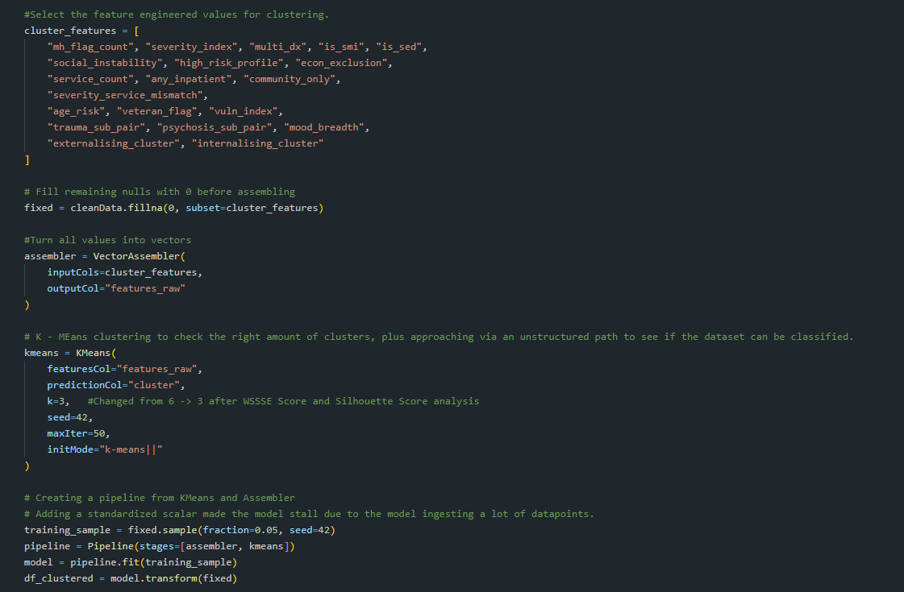
The input to the model consists of vectors containing 19 feature-engineered variables derived from the original dataset. The source dataset includes demographic information alongside indicators and occurrence records of various mental health disorders and substance use conditions. To enhance the model's ability to identify meaningful patterns, additional features were engineered to capture interactions between demographic characteristics and behavioral health conditions. These engineered variables were designed to analyze how different demographic groups are affected by specific mental health disorders or substance use issues, as well as to uncover population-level trends and relationships that may not be evident from the original variables alone. By incorporating these cross-interaction features, the model is better equipped to identify distinct client segments and reveal insights into the unique challenges faced by different populations. The Vector Assembler is then used to convert 19 distinct rows into a single list of vectors.
The next step of the model is defining the K-means model which at the initial stage was defined for 6 clusters due to a larger population and was later changed to 3 clusters or centroids after Silhouette and WSSSE (Within Cluster Sum of Squares) Scores.
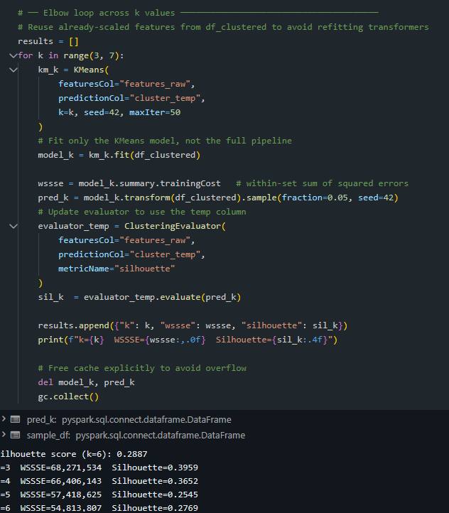
The optimal number of clusters (k) was determined using both the Silhouette Score and the Within-Cluster Sum of Squared Errors (WSSSE) metric. The Silhouette Score evaluates how well-separated and distinct the clusters are, with values closer to +1 indicating stronger cluster cohesion and separation. In contrast, WSSSE measures the compactness of clusters, where lower values indicate that data points are more closely grouped around their respective cluster centroids.
While the Silhouette Score and WSSSE exhibited conflicting trends across different values of k, the combined evaluation suggests that k = 3 provides the best overall clustering solution. Although larger values of k resulted in lower WSSSE scores, indicating more compact clusters, the Silhouette Score declined significantly beyond k = 3, suggesting reduced cluster distinctiveness and increased overlap. Therefore, k = 3 was selected as the optimal configuration, with k = 5 identified as the next best alternative. This choice balances cluster compactness with meaningful separation, resulting in a more interpretable and reliable clustering model.
Once the best k fit for the model is selected, a pipeline for the model is created to ensure the model is run for a sample size of 5% of the population.
Outcomes
The model was able to break the clusters into three distinct groups of various risk factors. The clusters were divided into (“High Risk”, “Low Risk “, “Medium Risk”) clusters where various factors like demographics, age, region, race, disorder reports were addressed and clustered.
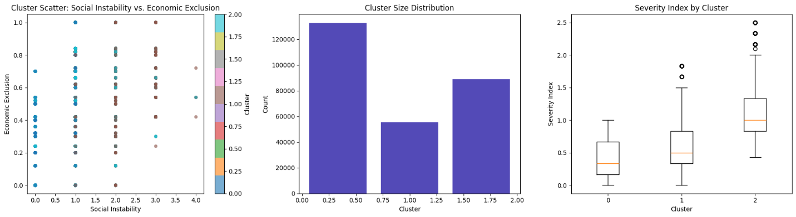
The model was also able to identify the correlation between Substance overdose across clusters and find how cases where patients with medium risk of severity often showed highest substance usage compared to people with low risk or high risk.
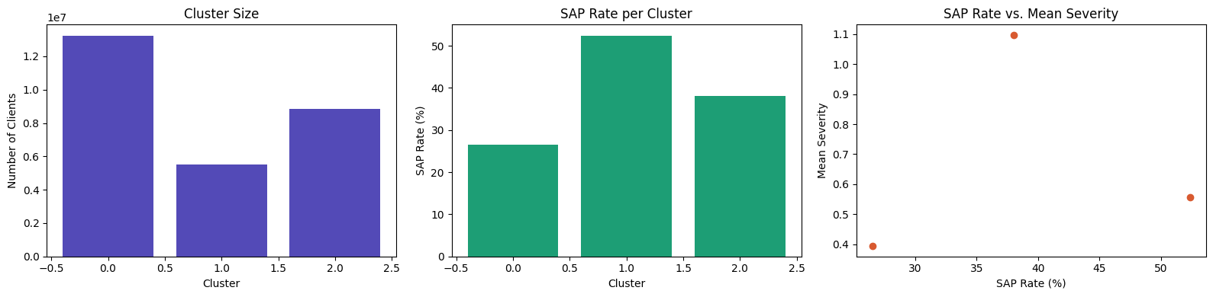
The visuals in the dashboard also demonstrate some correlational analysis, where factors like age showed significant relevance to real world scenarios, where young group (0 -11) were one of the highest vulnerable groups and yet had a lower substance usage. Factors like education and employment status also showed valuable insights within different populations in ensuring how a lack of either could lead to substance usage.
Dashboard
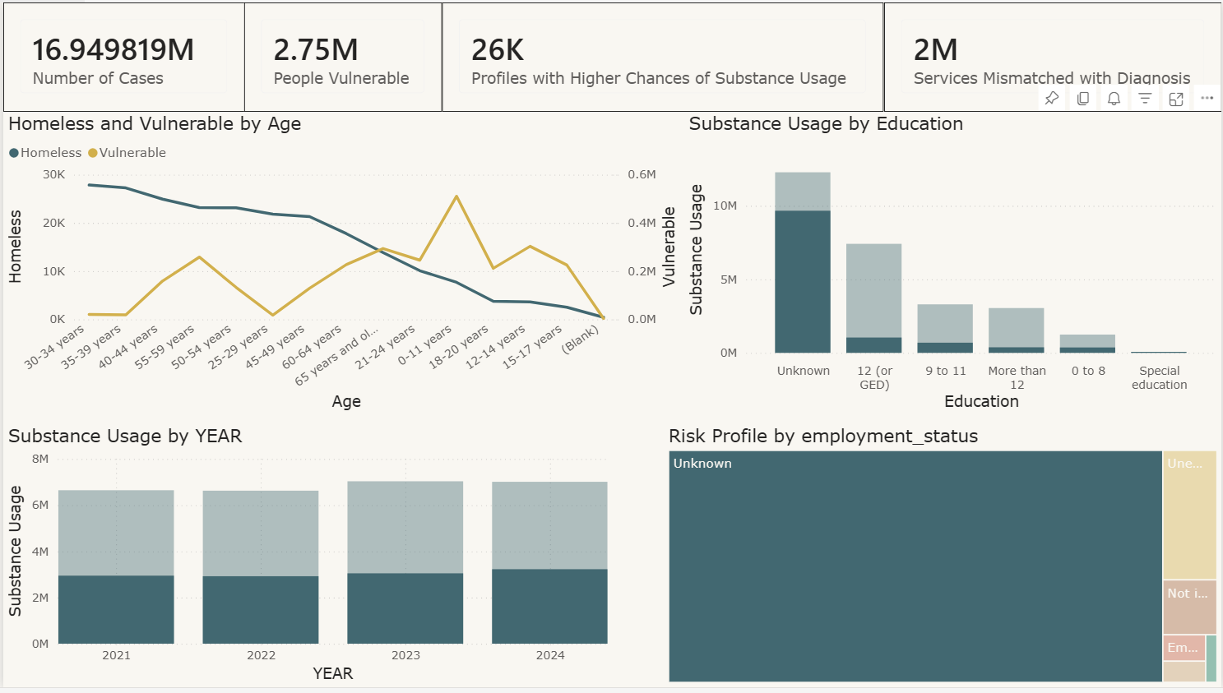
The Dashboard demonstrates the impacts of social and economic choices which could lead to usage of substances and increase the severity of mental health disorders. The dashboard tries to bridge the gap between various factors like economic stability, job security, isolation and various factors surrounding an individual to determine if the patient is a high-risk patient requiring extra attention.
Batch KPIs –
Vulnerable Population – Feature engineered a vulnerability index, showcasing the vulnerable population who are in risk of substance use or worsening of their mental health conditions.
High Risk Profiles – Feature engineered a risk profile index allowing the model to cluster different patients into different risk profiles, ensuring proper services are allocated to people based on need.
Mismatched Services – One of the leading factors for prolonging of mental health disorders and substance usage is either a lack of appropriate service or incorrect service provided to address a particular mental health disorder. This factor ensures if the patient is getting the right service with the right amount of severity associated with their condition.
Lessons Learned
The initial database consisted entirely of numeric values, which simplified the data cleaning process and facilitated feature engineering for the clustering model. However, while the numeric structure was advantageous for model development, it created challenges during the visualization and dashboarding stages. Relationships between features were represented only by numerical codes, making the results difficult to interpret and limiting the contextual understanding of the data. To address this issue, approximately 26 million values were mapped to their corresponding categories across all categorical features, transforming the data into a more meaningful and user-friendly format. This experience highlights the importance of ETL processes not only during data ingestion and model development but also throughout the analysis and visualization phases, where contextualization is critical for effective decision-making.
Proper Sampling of Data is critical in ensuring the model scales with the system as 30% of the Model took over 40 - 50 mins to execute. The model also had to avoid standardizing values by executing the model without a standard scalar which was causing it to exceed the memory limit for the model to process.

